
Setting up your account
Clinician enrols you on the service

You receive two emails from
no-reply@inhealthcare.co.uk

One confirms your registration

The other asks you to set up your account for the MyInhealthcare app

Follow up and discharge emails come from
no-reply@inhealthcare.co.uk

Download the app from the app store

If you have forgotten your password, please get in touch with someone from the project team

Logging in to the app
Enable training mode by swiping right and enter the environment code

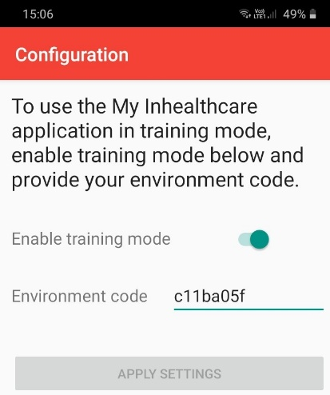
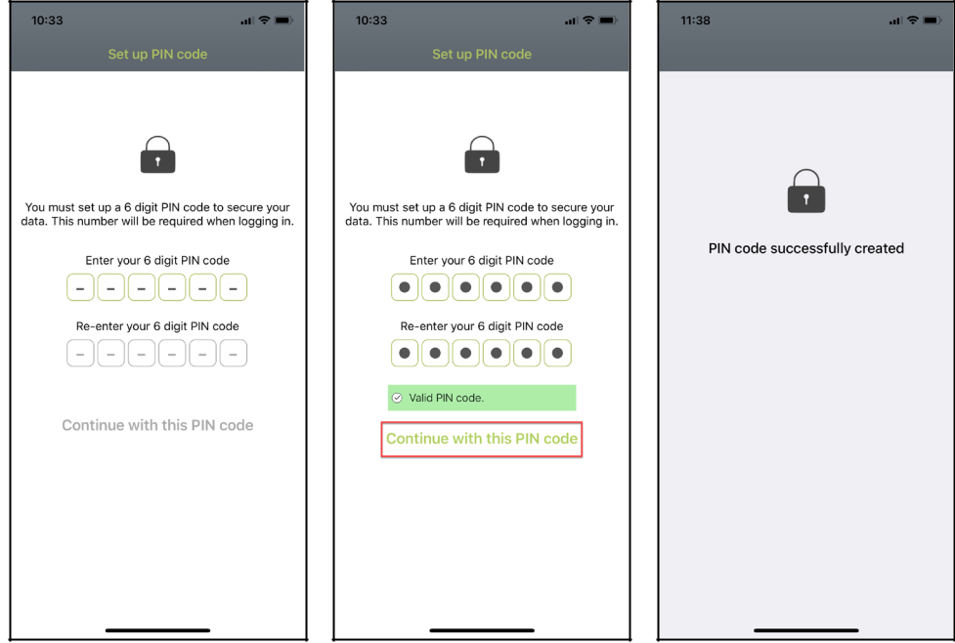
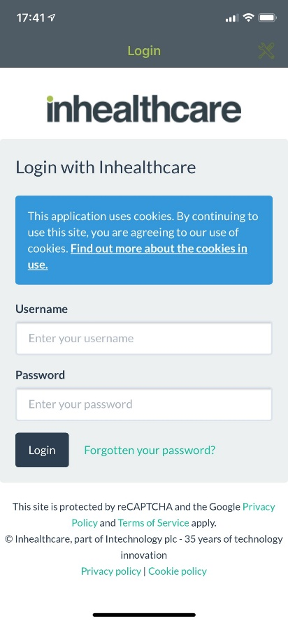
Then click apply settings

Click on the tools in the top right corner

A success message is displayed and then you will be asked to log in by using your username and password
Enter a 6 digit code, re-enter the 6 digit code to confirm and tap Continue with this PIN code.
You are prompted to set up a 6 digit code, this code will be required each time you log in to the app.

