

Guidance for running VIDEO Groups with Near Me





Version 2 May 2022
For review November 2022
Contents
Introduction 2
Process 3
Examples of use 5
General information & resources about near me 5
EXAMPLE pROCESS mAP 7
Appendix 1 caller information 8
Appendix 2 service provider information 11
Appendix 3 Getting your video group waiting area set up 12
Appendix 4 Risk factors to consideR 12
APPENDIX 5 ADDITIONAL MENTAL HEALTH CONSIDERATIONS 13

For the purpose of this guidance anyone from Health, Care or the Public sector who is involved in running the group will be referred to as a Service Provider. The term Caller describes the person who attends the group, the attendee or partcipant, and may refer to a patient, client, interpreter, carer, customer or service user etc.

Introduction

Near Me is transforming the way people access services in Scotland. It is a video calling platform used widely in Health, Social Care & the Public Sector powered by Attend Anywhere®. To date it has been used to support video calls between service providers & citizens with the option to invite additional participants into a call, with a maximum of 4 to 6 callers.
Attend Anywhere® has released the option of “Group Consulting” which can accommodate multiple callers. A separate Group Consulting waiting area will allow you to invite up to 60 participants per Video Group. Up to 30 callers can be viewed on screen at the same time with the option to scroll down through the callers. Multiple colleagues and staff with service providers roles can also join to support the delivery and running of the group.
From here the term “Near Me Video Group” will replace “Group Consulting”.
The Near Me Video Group platform is very similar to a standard Near Me waiting area platform for both providers and callers. You can send the entry link to callers by SMS or email, share your screen and use a chat function.
If you are new to Near Me or would like more general information, please see the section on Page 5: General Information & Resources about Near Me.

Process

Many of the process steps involved in running a 1:1 Near Me Video Call are similar to planning & conducting a Near Me Video Group. The graphic and tables below explore the steps which are unique to the Video Group functionality and those who are involved.

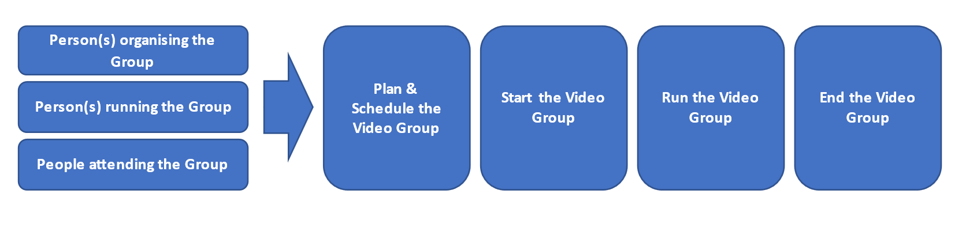

Plan & Schedule the Near Me Group
Person organising the Group.  (This may or may not be the person running the group) | - Ensure all staff who will be involved in delivering / facilitating the group are Near Me service providers for the designated Near Me Video Group waiting area. More information about how to do this can be found in “General information & resources about near me”  - Log into the group waiting area and see the “waiting area link section” for its joining URL (link).  - Invite presenters and/or other group facilitators to log in and join the session as Providers.  - Decide upon the group attendees (callers).  - Download the editable Groups Caller Leaflet and update it with the URL for your group waiting area and local contact information. For anyone needing more details instruction, a Basic Caller Guide is also available.  - Invite callers by sharing the Waiting Area link via email (Bcc), text, website, or letter. Include a copy of the edited Group Caller Leaflet.  - Make sure your callers are aware of ground rules and guidance that apply to virtual consultations. This may be locally agreed and will relate to short-notice cancellations, being on time, use of chat and etiquette etc.  - Consider a test call or a pre-group session to ensure everyone can join. See Test Call Checklist for guidance
Resources | Appendix 1 caller information
Technical | For guidance on technical set up and Group Waiting Area creation please see this page or apply to your local Near Me Organisation Unit administrator to set up a waiting area see appendix 3.

Start the Near Me Group on the day
Person(s) running the Group | - Log into Attend Anywhere and select the Near Me Video Group waiting area. Group waiting areas are marked with a purple banner  - Make sure your environment is appropriate for video calling. Consider your background, possibility of being interrupted etc.  - Familiarise yourself with the “Near Me Video Group” functions – appendix 2  - Gather the resources you need for the Near Me Video Group, make sure they are ready on your device to share when you need them.  - Consider the optimum number of providers required to enable the group to run smoothly. For example, one to deliver the content and one to monitor and respond to chat, take notes etc. Note that additional Service Providers can join directly into the Near Me Video Group without being admitted via the waiting area.  - Check the callers in the waiting area against your list of people invited.  - Is everyone there? Do people need help joining or is a reminder required?  - Follow local process for contacting callers who are not there. E.g., will the co-presenter need to phone the callers who are not there?  - Launch the session by Admitting callers.
People attending the Group | - Caller should have received, read, and understood any information provided plus consented to receive their consultation/treatment via the Near Me group link sent to them.  - Use the link to join the Near Me Group waiting area 5 minutes before the start of the session.  - Callers are automatically muted when they join the call.
Resources | - General information & resources about near me
Technical | - Only one group can run at any one time from a Near Me Video Group waiting area. This can be managed via a central timetable or by requesting the creation additional group waiting areas. There is no limit on the number of group waiting areas that can be created.  - Note that the system has a maximum call duration of 2 hours.

Run the Near Me Video Group
Person(s) running the Group | - Service Providers can disconnect unwanted callers before admitting all waiting callers.  - Admit or decline any late arrivals.  - Reply to Callers chat either publicly or privately.  - Remove callers form the Near Me Group once up & running for example if they are disruptive.  - They can also turn off the callers’ camera and/or microphone if needed.  - Make sure the callers are aware of the ground rules and etiquette that applies to Near Me Video Group.  - Look after yourself and have some water to hand.  - Account for the 2-hour limit and schedule a comfort break by 1½ hours for groups lasting longer to account for those callers who may have entered the waiting area early and prevent them being removed before the break.
People attending the Group | - Callers can only see other callers by their initials; however, the Service Providers names are visible to all.  - Minimise distractions at home such as television noise.  - Avoid running other software programmes at the same time e.g. gaming & video streaming. Understand the need to participate from a confidential space with good lighting - preferably front lit.  - Minimise interruptions from others in the home environment.  - Use the “Hand Up” feature if they want to speak.  - Use “Chat” to ask questions or comment.  - Adjust the performance of their connection if picture or sound quality is poor.
Local agreement | - Agree local process should the Near Me group fail for technical reasons. First, contact callers immediately and advise them to re-join the call to complete the Near Me Group or offered another group appointment at a later date. You can also contact the VC Support Team for help (vc.support@nhs.scot or phone 01224 816666).
End the Video Group
Person(s) running the Group | - End Near Me Video Group and inform callers about the feedback survey as they leave.  - Note that any caller-related information should be updated within your patient / client record system separately.
People attending the Group | - Complete end of call feedback survey.

Examples of use

These roughly fall into 3 themes:
- Patient Education/Teaching Groups i.e. Diabetes Management
- Talking/Therapy Groups i.e. CBT
- Physical Activity/Movement Groups i.e. Cardiac Rehab
A single group session could also contain a blend of the above themes

Providers should decide on the suitability of their callers to attend a Near Me Video Group by balancing the risks of not attending against those of attending.
For more information see appendix 4.

General information & resources about near me

 | If you are new to Near Me, visit this page as an introduction and watch this short video.
 | The video Using Near Me with callers gives you an overview from the perspective of the service provider.
 | Make a test call here to see what Near Me looks like for a caller entering your waiting area Your PC, laptop, tablet, or phone will need access to a camera and microphone. (NB This is a demo link only).
 | This video shows what your standard Waiting Area will look like when you are using it and some basic service provider instructions.
 | To learn more, view our range of resources i) Training videos here ii) Practical guidance for using features https://www.vc.scot.nhs.uk/near-me/guides/
 | For technical advice or to book on a live training session please contact the Video Conferencing support team vc.support@nhs.scot or phone 01224 816666
 | For all other information please see the TEC Near Me Website or contact the team directly at nss.nearme@nhs.scot

EXAMPLE pROCESS mAP
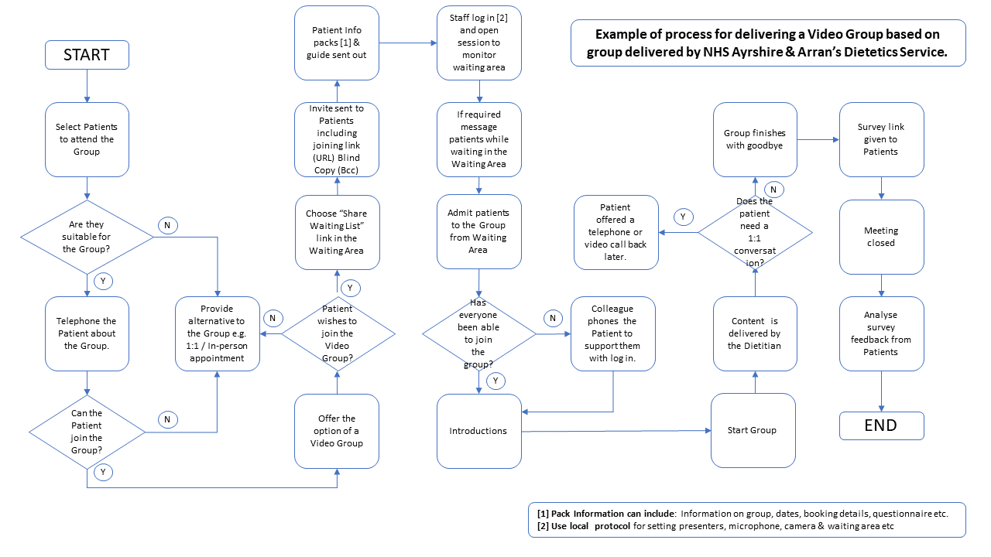

Appendix 1 caller information

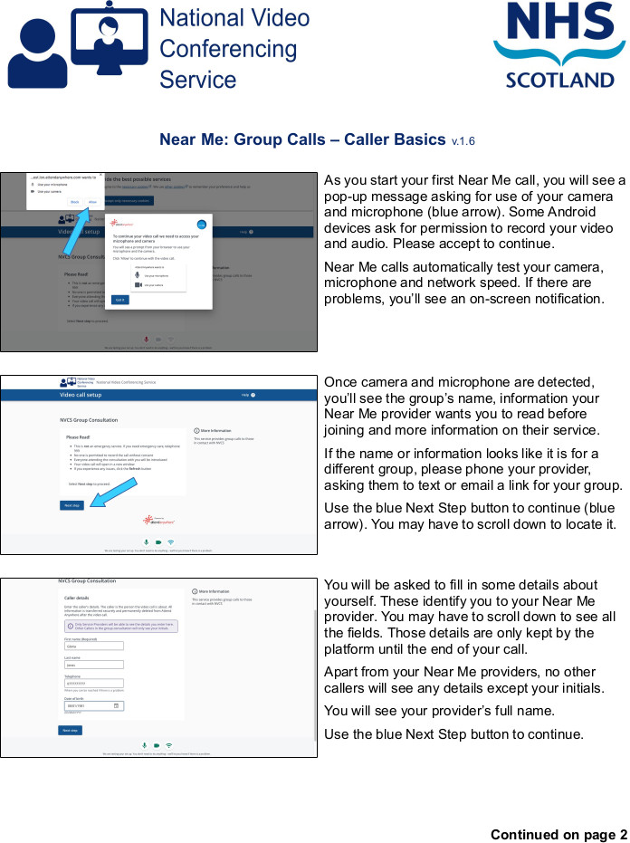
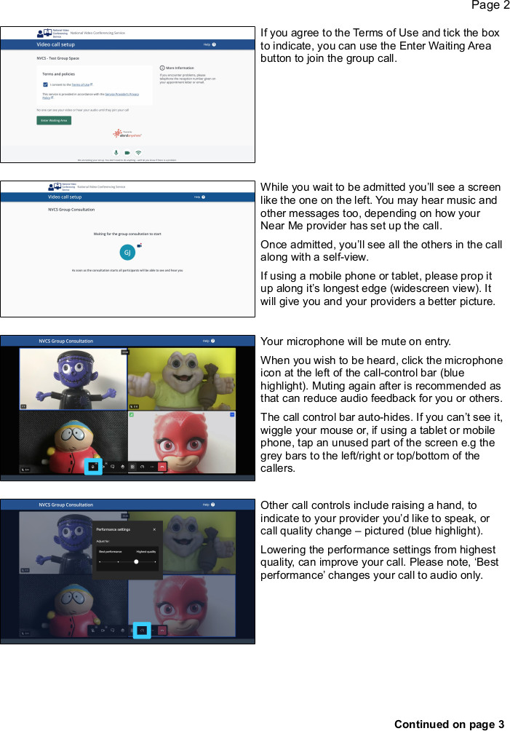
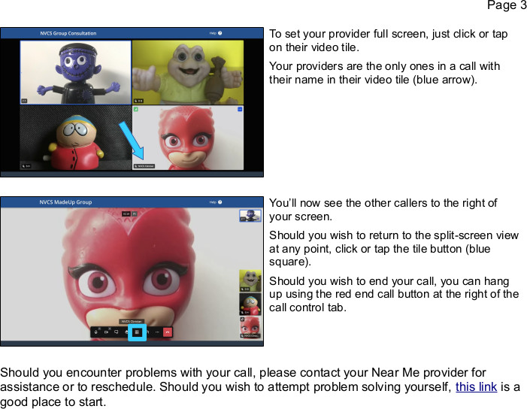

Appendix 2 service provider information

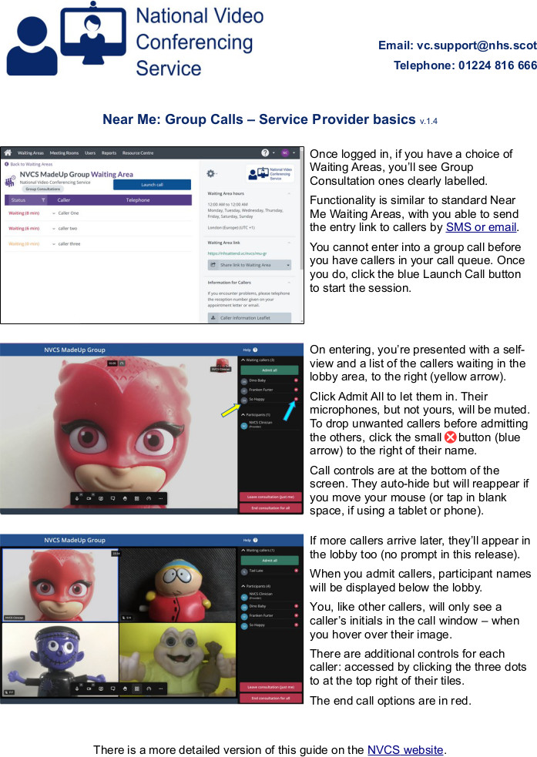

Appendix 3 Getting your video group waiting area set up

 |  | Points of note & who to contact
1 | Identify when you will be running your group | You can only run one group from one waiting area at one time. You can have as many groups as you like from that waiting area if they run at different times. If you have two / multiple groups which will be on at the same time you will need multiple waiting areas.
2 | What will you call the group waiting area? | If this is going to be used by multiple different groups, the name needs to be relevant to the services delivering the group as this will be on the communication to patients.
3 | Apply to set up your waiting area | Your Near Me Organisation Unit Administrator will enable this. This may be the clinical / service lead who has set up your standard waiting areas, or it may be a service request through local IT or the National VC Team vc.support@nhs.scot
4 | Identify which staff will be running the groups. | As you apply for your waiting area, please provide a list of the staff who will require service provider access.

Appendix 4 Risk factors to consideR

High Risk | Unknown Risk | Special Consideration
Medically unstable patients | New patients | Patients with sensory difficulties
Intoxicated patients | Unavailability of community response to a contingency plan | Patients with cognitive impairment
Actively aggressive patients | Unpredictable risk to self and others | Patients with incapacity
 | An unsuitable home environment for assessment | Patients unable to engage over VC
 | No telephone connection at patient’s home for back up | Patients requiring an interpreter
 | Inadequate technology or connection speed | Patients who decline

APPENDIX 5 ADDITIONAL MENTAL HEALTH CONSIDERATIONS

Mental Health Considerations
Clients should be informed and give consent to receiving treatment via a video group consultation. Informed consent requires three components:

• Patient is provided with the information required to make the decision.
• Patient has capacity to make the decision.
• Patient makes the decision voluntarily.

Capacity means the ability to understand the information relating to a particular decision, together with the ability to weigh up the pros and cons of deciding one course of action versus another, and then, communicating that decision.

Details of risks and appropriate behaviours should be detailed in the consent, this aligning with normal expectable behaviours in face to face treatment or use of Near Me one to one video consultation.
When considering whether to invite a client to attend a group consultation consider the following:

1. As a clinician, am I concerned I may not be able to accurately assess the patient?
2. Are there risks that I am aware of which I feel cannot be adequately managed?

If the answer is yes to either of the above questions, consider offering a one to one video or face-to-face appointment.
All patients should receive a comprehensive clinical assessment by an appropriate clinician. This should include an assessment of suitability for remote group consultations, including risk to self and others. Individual services should consider the relevant risk scenarios in their patient population and develop their own response plan accordingly.

Risk factors to consider include:
High Risk | Unknown Risk | Special Consideration
Patients with known high risk of violence | New patients | Patients with sensory difficulties
Patients with known high risk of suicide | Unavailability of community response to a contingency plan | Patients with cognitive impairment
Medically unstable patients | Unpredictable risk to self and others | Patients with incapacity
Intoxicated patients | An unsuitable home environment for assessment | Patients unable to engage over VC
Actively aggressive patients | No telephone connection at patient’s home for back up | Patients who decline telepsychiatry
 | Inadequate technology or connection speed | Patients requiring an interpreter

The above list is only advisory. Following consideration of the risks, the assessing clinician may decide that these can be adequately managed on the video call.
Client ends call before end of session:

- If client ends the video call session prematurely someone should call the client back via telephone as agreed at 1st appointment.
- If client does not take the return call inform the relevant services according to the assessed level of risk. This may involve GP, local duty teams or emergency services.
- If client does take the return call establish if they are safe, not in need of assistance and not in distress, discuss the importance of not ending sessions prematurely.

Establish if it is still appropriate to proceed with the group consultation, or if an alternate method of service delivery is required.

For more detailed guidance on running video groups in Mental Health click here

